ICPM-5 Special Issue instructions
Regular Article Submission

Submitting your ICPM-5 Special Issue article.
Prepare your manuscript in the “standard” format. Ideally, please use Times New Roman 10pt font, double-spaced.

To register and create login please go to:
http://submission.begellhouse.com/usr/register.html

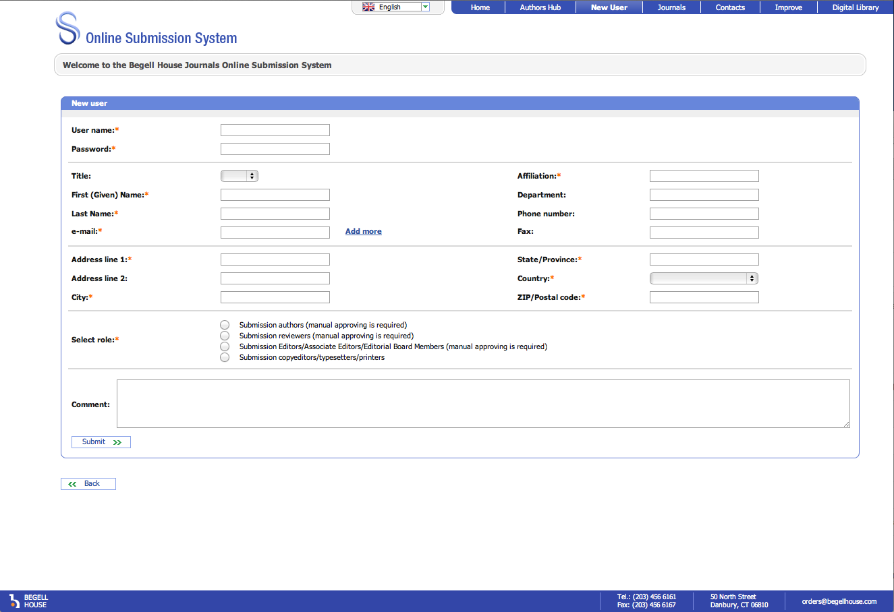

Please allow 1-2 days for your registration request to be processed. You should receive an email once your registration is completed (just in case, please check your spam folder).

To submit your ICPM-5 Special Issue article please go to:
http://submission.begellhouse.com/usr/login.html

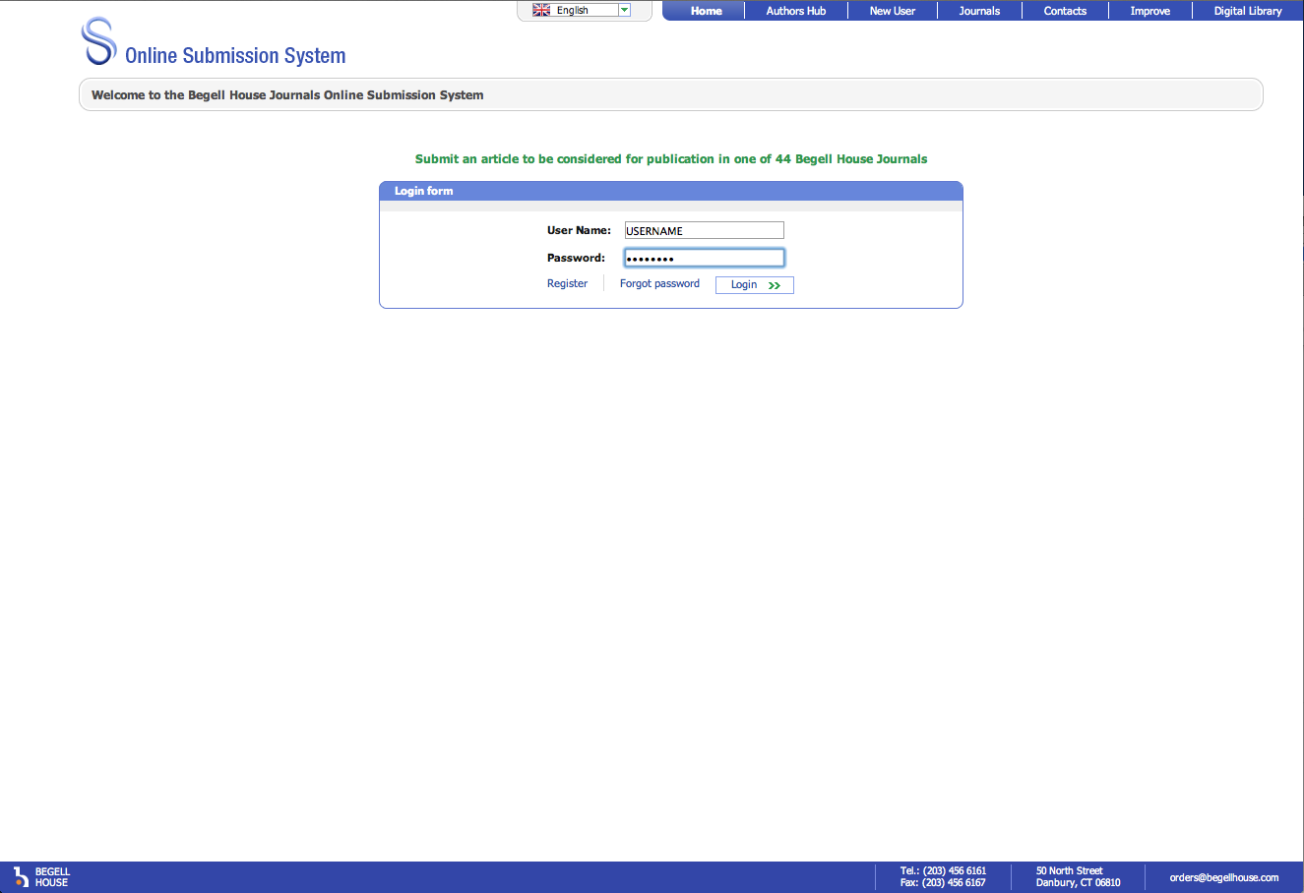

Once logged in, please select “Author” link.
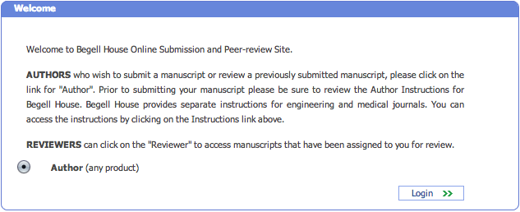

Click “Submit a new article”.
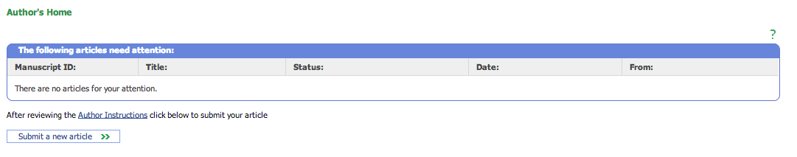

In the drop-down menu please select “Plasma Medicine” under the Journal selection and click “Next”.

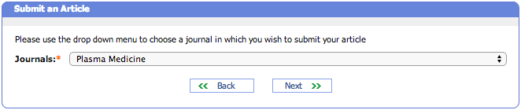

Please fill out the required information: Title, Keywords, and Abstract and click “Next”.

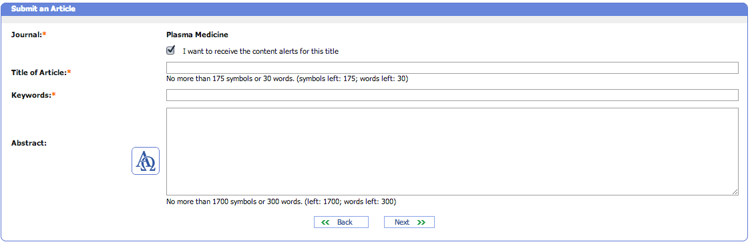

Fill out all the contact information for the authors and click “Next”. Please note, you will be the Corresponding Author for this paper so please make sure you are available to answer requests from the Reviewers, Editors, and the Journal staff.

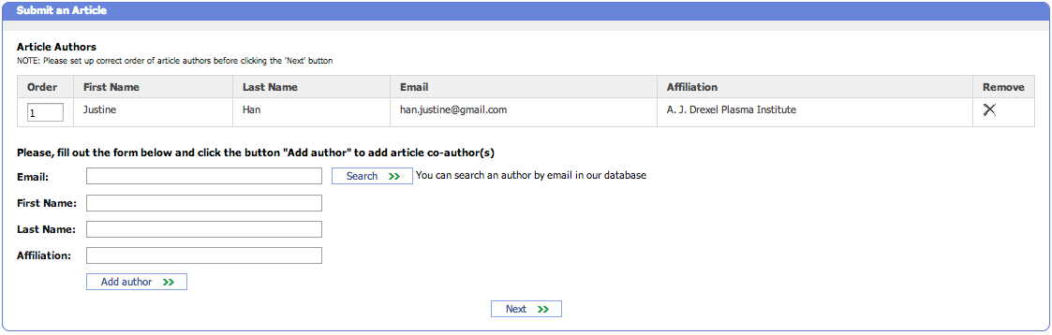

Select “Choose File” and upload the file(s) for submission. Multiple files can also be uploaded as a zipped folder. Once uploaded, the file name can be edited using the icon under the “Edit” column. The files that have been successfully uploaded will appear on the screen under “Source Files.”

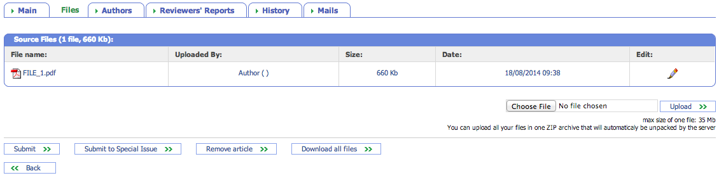

Once all files are uploaded and all fields are complete, select “Submit to Special Issue” to finalize the submission.

Done.

Please wait for further communications from the journal.

